PRACTICAL 6
Aim:-Study of Parts - Serial, Parallel, USB, PS2, Audio ports.

- Serial


A serial port is a physical interface used for serial communication, transmitting data one bit at a time over a single wire. Historically common in computers for connecting peripherals like modems and printers, they are now less prevalent on modern desktops but remain important in specific industries and for certain devices
Key aspects of serial ports
Serial Communication
Physical Interface
Legacy Interface
RS-232 Standard
Connector Types
UART:

- Parallel Port
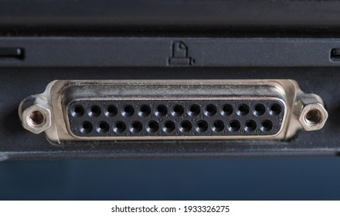

A parallel port is a type of computer interface that transmits multiple bits of data simultaneously over multiple wires, unlike serial ports which transmit data one bit at a time. It was commonly used to connect peripherals like printers, scanners, and external storage devices. The original parallel port was known as the Centronics port, and later versions like EPP and ECP offered faster speeds.

Parallel ports send data in parallel, meaning multiple bits are transmitted at the same time over separate wires.
This contrasts with serial ports, which send data one bit at a time sequentially.
The parallel port typically uses a 25-pin connector (DB-25).

- USB (Universal SERIAL Bus)
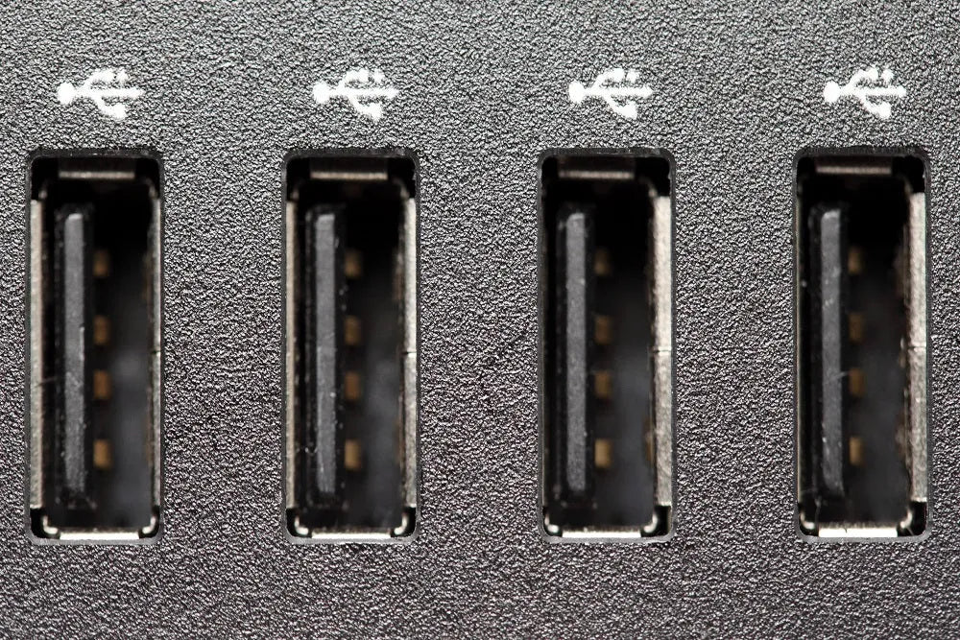

A USB port, which stands for Universal Serial Bus port, is a standardized connection point on computers and other devices that allows for the transfer of data and power between devices. It's a versatile interface that has largely replaced older connection methods like serial and parallel ports, and is used to connect a wide range of peripherals such as keyboards, mice, printers, and storage devices.

PS2()
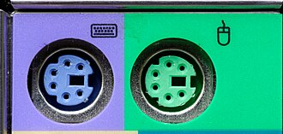
A 6-pin mini-DIN connector used for connecting some keyboards and mice to a PC compatible computer system. Its name comes from the Personal System/2 series of personal computers, which was introduced in 1987.

- Audio Ports
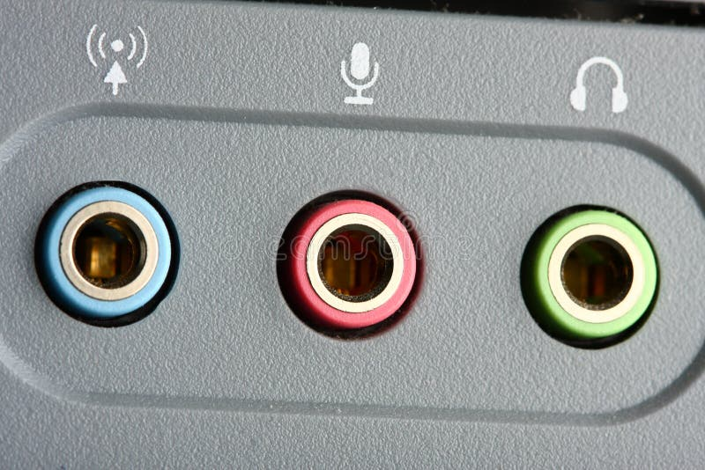

Audio ports are physical interfaces on devices that transmit audio signals. They function as either inputs, receiving audio signals (like from a microphone), or outputs, sending audio signals (like to speakers or headphones). Common examples include the 3.5mm headphone jack, RCA connectors, and optical/coaxial ports.

